**Mini-project description**

1. Detail requirement

* Eclipse application
* Java JDK 1.8+

1. Usecase diagram explanation:

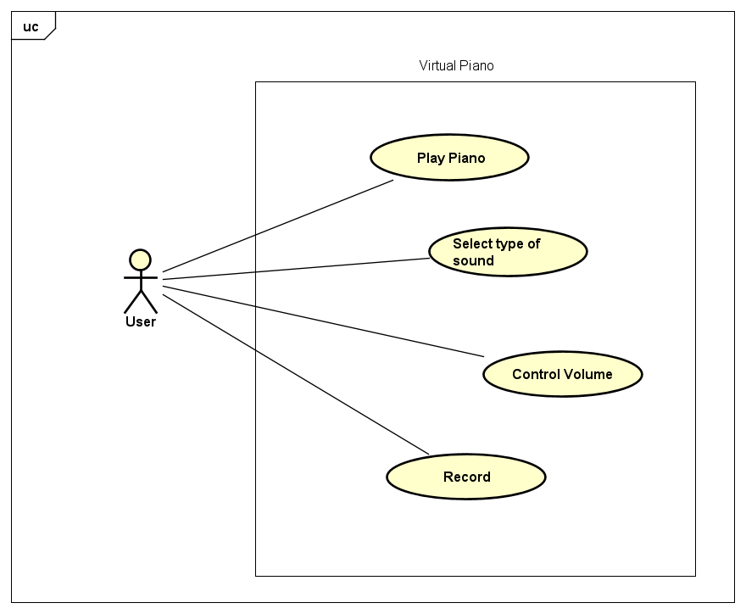

The program have 4 use case: play piano, select type of sound, control the volume and record the piano.

Play Piano: have a piano GUI that when user click on the piano, the system will play the correspond note of that key.

Select type of sound: Hava 3 type of sound that can play on piano is that: Piano, Guitar, and Drum. Piano is the default sound, user can select another to play.

Control volume: Have a slider bar to change the volume from max to min.

Record: User can record the play of piano, user can pause between the recording. After record done, user can listen again the recording. User can record unlimited times.